How Malapportioned is the Electoral College? A Multiple Indicators Historical Perspective: 1790-2016

ABSTRACT

We examine the claim that the U.S. Electoral College (EC) is very badly malapportioned, and we consider present levels of malapportionment in historical perspective using apportionment data going back to the Founding. We show that the common wisdom about the extent of malapportionment in the EC is exaggerated once we distinguish between large differences in population share and EC vote share between the most under represented and the most overrepresented state, since the states with the greatest malapportionment do not make up a large share of the EC vote. Indeed, when we measure malapportionment using the metric that is most common is the electoral systems literature to measure seats-votes disproportionality (Gallagher 1991), we find that the EC has little in regards to mechanical malapportionment. Second, we show that contemporary levels of malapportionment are below historical levels, returning to levels not seen since the mid 19th century.

Word Count: 6381

Keywords: Malapportionment, Electoral College, Gallagher Index, Gini Index, Elections, Representation, Voting
I. Introduction
After the 2016 election, the Electoral College and the popular vote have now diverged in two of the past five elections. In a September 13th, 2017 interview with CNN’s Anderson Cooper, Clinton, the losing candidate, said "I think [the Electoral College] needs to be eliminated." Malapportionment bias is often implicitly blamed for causing the divergence. The reasoning goes that because the states are not weighted exactly according to their populations, some voters are given a greater voice in choosing the president. While there are both proponents and opponents of the U.S. Electoral College (EC), it would seem that there can be little dispute that the Electoral College is badly malapportioned (Edwards ???). Some have even suggested that “the malapportionment in the Electoral College, which never had a very good justification, continues to exert influence today” (Klarman 2016). The translation of votes into seats rarely leads to a one to one ratio, and especially in Westminster systems of government such as the one employed in the US (Johnson 2002). Taagarpera and Shugart consider malapportionment as a pathology of electoral systems (Taagepera and Shugurt 1989, 2017). Robert Dahl claims that malapportionment leads to a violation of “one person, one vote”, a necessary condition of democratic governance from a democratic theory point of view (Dahl 1971). It is hard to imagine a near-proportional translation in the Electoral College given the existence of an overweighting of small states induced by the two seat “federal bonus.” Electoral College outcomes regularly have exaggerated outcomes vis a vis the popular vote, giving the appearance of significant malapportionment (Riggs et al 2009, Pattie and Johnson 2014). Here we offer analyses intended to challenge this common claim. We show that those who think the Electoral College is badly malapportioned will be found to be correct if we judge malapportionment by the usual metrics used to judge compliance with “one person, one vote” in contemporary U.S. voting rights law, but that other metrics, including the metric that is most common is the electoral systems literature to measure seats-votes disproportionality (Gallagher, 1991), leads us to the conclusion that the EC behaves much like a proportional representation system.
To understand Electoral College effects, we need to distinguish the mechanical effects of the Electoral College that we may think of as “malapportionment related” (i.e., due to discrepancies between a state’s EC vote share and the state’s population or House delegation share), which arise simply because EC vote allocations equal the size of a state’s U.S. House delegation plus the size of the state’s U.S. Senate delegation, from effects that are tied to the distribution of the votes across states in each election. The former applies throughout any given redistricting decade; the latter are election specific. Early work has shown that election specific partisan bias is either not statistically significant, and when it is, it does not consistently favor one party. It is only the institutional sources of malapportionment that we will consider in this article.
The first source of malapportionment bias is due to the fact that even representation in the House of Representatives is not perfectly proportional to population when we look across states rather than within-states. There are rounding issues (the so-called integer allocation problem); and each state, no matter what its population, is guaranteed at least one seat in the House of Representatives (Ladewig and Jasinski, 2008). The method of apportionment itself can affect voting power (Edelman 2015). The second source of malapportionment bias arises because of the two seat “bonus” that comes about because every state gets two U.S. Senators. Seats in the U.S. Senate are, of course, not allocated based on state population. Thus, assigning seats in the Electoral College based on a combination of population (only proxied by the number of seats a state has in the U.S. House) plus two (for the number of Senators) necessarily introduces a disproportionality between EC seat share and state population share, and this disproportionality is greatest for the smallest states that are overrepresented in the EC relative to their population.
We calculate three types of malapportionment indices: one set of measures is based on discrepancies between the two states exhibiting, respectively, the greatest and the least discrepancy between population share and EC vote share; another type is based on average or total discrepancy measures, such as those used to measure disproportionality in seats-votes relationship; the third type is based on measures such as the Gini index that look in some fashion at the entire distribution of discrepancies. We show that it is the first type of measure that leads the public to believe that malapportionment effects in the EC are very large. Once we look instead at a population-weighted average malapportionment bias, or at measures that look at the whole distribution of discrepancies, since the states with the greatest malapportionment do not make up a large population share, we arrive at quite different conclusions about the extent of malapportionment bias in the EC.
Unlike most previous work on the EC (Adkins and Kirwan, 2002 is a notable exception), we distinguish between effects of the two sources of malapportionment bias, one based on lumpiness effects in allocating integer numbers of House seats to the states and the requirement that every state have at least one House seat, and the other based on the two seat Electoral College “Senate bonus” given to each state regardless of its population. Using analogues to the two measures most commonly used to assess seats-votes disproportionality, the Loosemore and Hanby index (1971) and the Gallagher index (1991), we are able to distinguish the impact of the House malapportionment factor from that of the two-seat bonus. We show that the former has been declining in recent decades, despite the freezing of House size at 435 that occurred in 1929; while the latter has remained flat during that same period. Although the latter effect is the more substantively important, we find both malapportionment effects to be quite minor in the aggregate. These analyses enable us to demonstrate that the discrepancy between popular vote outcome and EC outcome that occurred in 2000 and 2016 cannot be blamed on an increasing institutional malapportionment bias in recent decades, since contemporary levels of malapportionment are below historical levels, returning to levels not seen since the mid 19th century.

II. Measures of Disproportionality Between State EC College Vote Share and Population Share

We wish to measure “malapportionment bias” in the Electoral College in a way that does not depend upon the actual distribution of votes in any given election. Below, we offer six different indicators of the way in which there is a disproportionality between a state’s EC vote share and its population share. Two measures are based on the difference between the largest and smallest discrepancies; two other measures are linked to the overall or average disproportionality. We will pay particular attention to variants of each of the latter that allow us to distinguish the effects of House malapportionment and the effects of the two-seat Senate bonus. Finally, we consider two further measures that look at the entire range of population and EC seat share discrepancies, such as the Gini Index.

Measures based on highest and lowest disproportionalities
(1) One measure of potential malapportionment effects is to look at the discrepancy between Electoral College allocations and state population in a way that is directly analogous to the method that courts (and expert witnesses) in one person, one vote cases in the U.S. use to measure malapportionment within a state. The standard way to measure compliance with a “one person, one vote” standard is to examine the total population deviation for a state’s legislative (or congressional) districts. The formula for calculating the total population deviation is

TOTAL POP DEV = (1)

which can be rewritten as

TOTAL POP DEV =


(2) An alternative approach would be to simply report the ratio of the largest congressional district to the smallest district.
MAX/MIN = (2)

As long as population continues to grow, this index is essentially unbounded. However, since we are interested in malapportionment across states rather than within states, and because we are dealing with a weighted voting rule where states may vary in the number of EC seats they receive, we will do both comparisons in terms of the ratio of state population share to state electoral college vote share, i.e., in terms of the number of people in the state per Electoral College vote in the state.

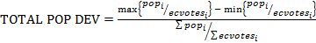 (1)’

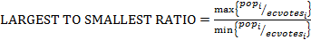 (2)’

Information for both the EC version of the total population deviation measure and the EC version of the ratio measure are reported in Table 1 below. We show the same information in Table 1 in graph form in Figures 1 and 2.
<Table 1, Figures 1 and 2 about here>>
Table 1: Measure of Discrepancy between Largest and Smallest Average Electoral Populations
Year | (Min)  Persons/Seat | (Max)  Persons/Seat | (Ideal) Persons/Seat | Max/Min | Total Population Deviation
1790 | 17206 | 32949 | 27713 | 1.915 | 0.568
1800 | 15122 | 34559 | 28709 | 2.285 | 0.677
1810 | 18168 | 37738 | 31134 | 2.077 | 0.629
1820 | 18404 | 45704 | 36226 | 2.483 | 0.754
1830 | 24300 | 52835 | 43600 | 2.174 | 0.654
1840 | 26028 | 69139 | 60642 | 2.656 | 0.711
1850 | 23149 | 90618 | 76843 | 3.915 | 0.878
1860 | 17488 | 120525 | 99584 | 6.892 | 1.035
1870 | 13288 | 125222 | 103402 | 9.424 | 1.083
1880 | 20755 | 142763 | 123121 | 6.878 | 0.991
1890 | 15785 | 166755 | 139167 | 10.564 | 1.085
1900 | 14112 | 186382 | 156738 | 13.208 | 1.099
1910 | 27292 | 202525 | 172582 | 7.421 | 1.015
1920 | 25802 | 263605 | 198254 | 10.216 | 1.199
1930 | 30353 | 267831 | 230298 | 8.824 | 1.031
1940 | 36749 | 286790 | 246716 | 7.804 | 1.013
1950 | 42881 | 330819 | 280305 | 7.715 | 1.027
1960 | 75389 | 392930 | 333314 | 5.212 | 0.953
1970 | 100127 | 444804 | 377717 | 4.442 | 0.913
1980 | 133950 | 503572 | 421089 | 3.759 | 0.878
1990 | 151196 | 551112 | 462286 | 3.645 | 0.865
2000 | 165101 | 616924 | 524157 | 3.737 | 0.862
2010 | 189433 | 678945 | 575809 | 3.584 | 0.850

Figure 1: Ratio of the Largest and the Smallest State by (Average) Population per EC vote: 1790-2010
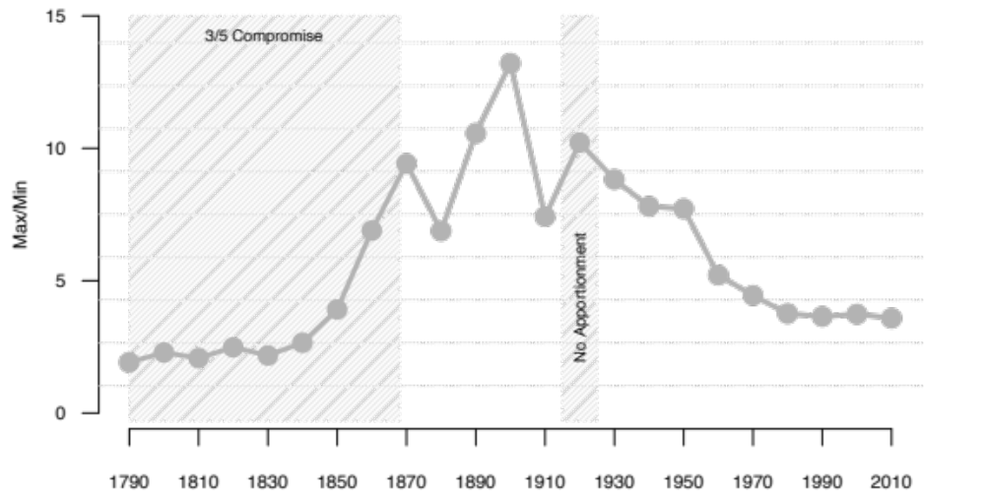

Figure 2: Total Population Deviation for Electoral College Votes, 1790-2010
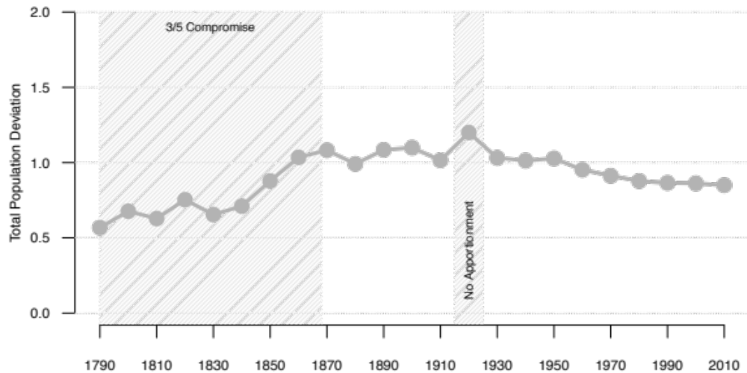

Since both measures focus on the same two states, the two EC disproportionality measures defined above are quite highly correlated, with a correlation of 0.90. However, when we compare Figures 1 and 2, EC Total Population Deviation appears to show a more muted effect, because we are directly taking ideal population into account.
The degree of malapportionment we expect to see in these two measures is affected by the size of the smallest state, since in all but the 1790, 1830, and 1850 decades of redistricting it was the smallest state which was the most overrepresented. Moreover, both measures --either explicitly, for the total population deviation measure, or implicitly, for the ratio measure -- consider ideal population size. Thus, these malapportionment measures are also affected by the size of the House.
In the early period of the U.S., House size increases tended to closely parallel overall population growth, with the House size more than doubling between 1790 and 1837, while the number of states grew from 15 to 26. As is apparent from Figures 1 and 2, in terms of our two measures, these early decades are also the most equitable in terms of EC malapportionment. Because the House size was frozen at 435 in 1913, and the number of states has been the same since 1960, we might expect that malapportionment would have grown in recent decades. And yet, this is not what the data in Figures 1 and 2 show. Instead we see declining malapportionment over the period in question. We will return to consideration of this puzzle later after we seek to disentangle EC malapportionment effects caused by malapportionment in the House of Representatives from that caused by the two-seat bonus.

Measures based on overall or average disproportionalities
The next two measures we present offer different ways to portray how lack of a perfect fits between population share and EC vote share might generate discrepancies between popular vote and EC vote outcomes. These measures all consider disproportionalities between EC share and population share in all states, not just the two states that are the furthest away from population share based allocations. These measures are, however, still a priori ones in which we do not consider the actual votes in any election as these were distributed across the states. By again tracking each of these measures over time, we can see the a priori extent of potential malapportionment-induced bias. Also, most importantly, we present variants of each of two of these measures that allow us to compare the effects of House-centric malapportionment bias from that induced by the two seat “Senate bonus.”
(3) The next two measure of disproportionality are drawn from the literature on electoral systems. The Loosemore-Hanby index (Loosemore and Hanby, 1971) and the Gallagher index (Gallagher, 1991) have long been used to show the disproportionality between the cumulative share of votes a party gets for all its candidates and the seat share that the party receives. Loosemore-Hanby measures the summed absolute differences between seats and votes, while Gallagher’s index, often referred to as a Least Squares measure, weights each observation by the size of the deviation, i.e., it squares the deviations -- doing so puts more weight on larger deviations, while discounting smaller ones.
In the Electoral College context, the Loosemore-Hanby index is defined by the equation
(3)
and the Gallagher index is defined by the equation
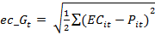 (4)
where EC_{i} is state i’s proportion of the electoral college and P_{i} is a state’s proportion of the total population.
Both indices are constrained to a range between 0 to 1, with values near zero indicating low disproportionality. It is apparent from Figure 3 that both measures are very low. We expect that average malapportionment will seem much lower in these measures than in the two ways we have previously calculated malapportionment, since the previous measures focus on only the two states with the largest and the smallest discrepancies.

<< Figure 3 about here >>
Figure 3: Loosemore-Hanby and Gallagher Indices for EC Population Discrepancies, 1790-2010
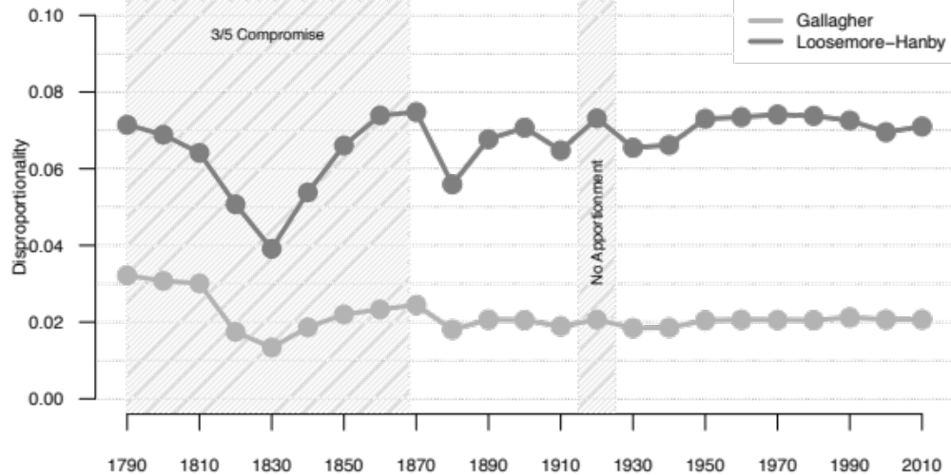

Loosemore-Hanby is sensitive to small deviations between population share and EC share, whereas the Gallagher measure weights small deviations less than it would large deviations, since it is squaring the size of deviations. Nonetheless, both measures are remarkably flat in the post-Baker v. Carr era. The Gallagher measures shows especially low levels of disproportionality. Indeed, for both measures, the numbers shown in Figure 3, while not as small as the party-based disproportionalities reported for the most highly proportional electoral rules in use world-wide, those of Netherlands and Israel, are comparable to the partisan disproportionalities in other western European democracies. This should not be that surprising, given the small impact a small overrepresented state might have on the total amount of disproportionality in the Electoral College, but it flies in the face of the common wisdom about how badly malapportioned the EC is supposed to be. For a full analysis of malapportionment in the comparative perspective, see Samuels and Snyder (2001). Using the same Loosemore-Hanby measure we have used above, they find that Tanzania has the greatest discrepancy at 0.2619 while Latvia has the lowest of any lower legislative chamber with geographic divisions at 0.0065. Malapportionment in upper chambers are much greater, including in the United States. The Electoral College is essentially mixture between upper and lower chambers, but more closely resembles lower chambers, which are characterized by lower levels of malapportionment, than it is of upper chambers, which can have disproportionalities as high as 0.4852 in Argentina.

(4) In order to compare the magnitude of disproportionalities in the EC vote generated by House rounding and the rule that all states must have at least one seat in the House with that caused by two seat Senate bonus, we can generate Loosemore-Hanby and Gallagher measures for the disproportionality between a state’s population share and its share of House seats.
Now, the Loosemore-Hanby index is defined by the equation
(5)
and the Gallagher index is defined by the equation
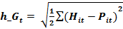 (6)
where H_{i} is a state’s i proportion of the Electoral College in each reapportionment decade and H_{i} is a state’s proportion of House members in that decade. We refer to the earlier measures as EC weighted measures and the present measures as House-weighted measures.
We show in Figure 4a the comparison between the EC disproportionality and the House disproportionality time series for the Loosemore-Hanby measure and we show in Figure 4b the comparison between the EC disproportionality and the House disproportionality time series for the Gallagher measure.

<< Figure 4 about here >>

Figure 4a: Loosemore-Hanby Indices for EC-Based Discrepancies and House Based Discrepancies, 1790-2010
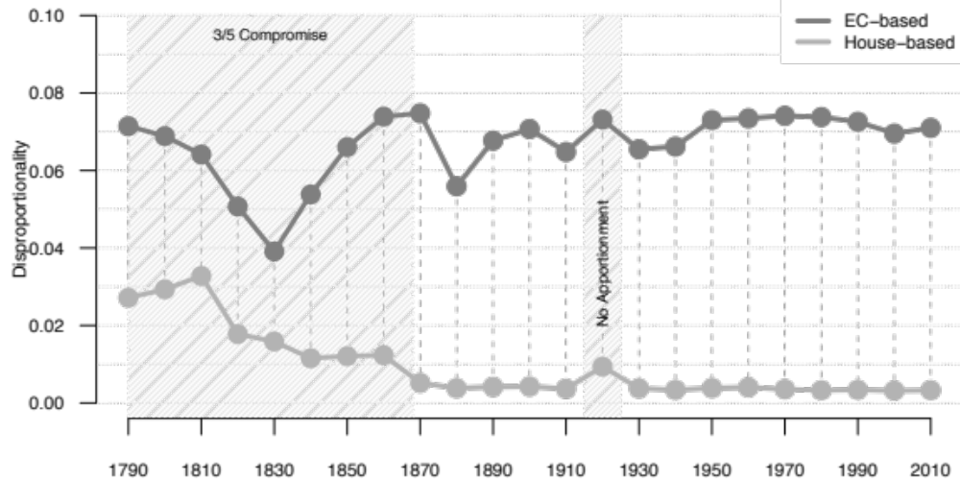
Figure 4b: Gallagher Indices for EC-Based Discrepancies and House Based Discrepancies, 1790- 2010

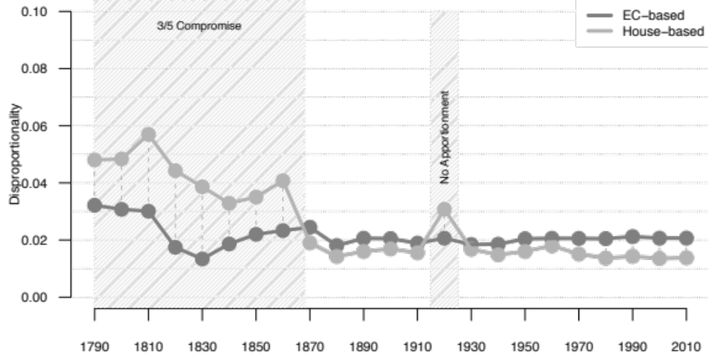
Figure 4a and Figure 4b tell similar stories concerning what has been happening to malapportionment in recent decades, namely, that it is flat or even trending downward.

Other Measures based on the total distribution of discrepancies

(5) Another way to think about malapportionment and disproportionality is to order the states from smallest in population to largest, adding up Electoral College votes along the way until we reached a majority of Electoral College votes. We then find the proportion of national population that was in that set of states, and use that as a measure of malapportionment. If the EC vote allocations perfectly matched population share, that proportion would be 50%. However, it is possible for the population so calculated to be (slightly) above 50% since we are adding integer numbers of Electoral College votes, and adding the state needed to create a population majority may yield a population sum above 50%. We show the time series for this measure in Figure 5. But we also show in Figure 5 an alternative way to calculate the minimum population needed to control a majority of EC votes, namely one where we order states not by population but by degree of overrepresentation relative to population, from most overrepresented to least overrepresented. As is apparent from Figure 5 these two measures need not coincide, nor is it always the case that one provides a higher estimate of minimum population than the other. Moreover, again due to peculiarities of rounding, it is possible for some of other set of states to actually generate a lower population value. The solid black line in Figure 5 indicates actual minimum population needed, and it is the one we use later when we report correlations across pairs of measures.
Comparing other measures with this one allows us to isolate two aspects of malapportionment; that which results from the winner take all nature of the Electoral College, and that which derives from deviations from one person, one vote allocations. The latter is better captured in this measure than in our previous ones.

<<Figure 5 about her>>

Figure 5: Minimum Proportion of the Population Need to Secure Electoral College Majority

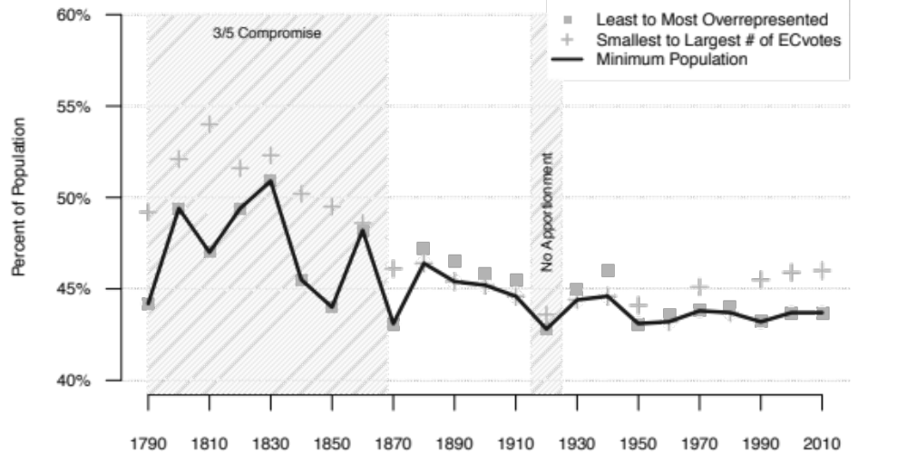

When we look at the black line in Figure 5 as our measure of population disproportionality, we do see a long-term increase in disproportionality, as the population needed to control a majority of the Electoral College has fallen -- but with far from perfect monotonicity in the time series even if we exclude the slavery period. Moreover, if we look only since the House size was frozen, though the population proportion remains near the historical low recorded in the decade where there was no apportionment, there is no real-time trend in these recent decades.
(6) Finally, we could develop a Gini Index measure of a priori inequity in apportionment based on a Lorenz curve, paralleling a standard way of looking at inequity in income distribution (see e.g., Bai and Lagunoff, 2013). We would do so by again arranging the states from most underrepresented to most overrepresented in terms of the EC vote to state population ratio and then plotting the cumulative distribution of state EC vote share against the cumulative distribution of the population vote share for those same states to give us a Lorenz curve. We could then measure the area between that curve and the 45-degree perfect equality line (where each states’ EC share equals its population share) so as to calculate the Gini Index for these two cumulative distributions.
We illustrate Lorenz curves for decades separated by a 40-year interval in Figure 6, and we show the full-time series for the Gini index in Figure 7. The Gini Coefficient is calculated using the ineq library package in R. The Gini Coefficient is calculated in the same manner as income inequality would be but using, instead of income, cumulative values of population and EC share. The Gini index varies between zero and one. A value of zero indicates zero disproportionality. As is apparent from these figures, as measured by the Gini coefficient, the disproportionality generated by the Electoral College is quite minimal, with the data series remarkably flat in recent decades, and actually (trivially) lower in 2010 than in previous decades in the post-Baker v. Carr era.

<<Figure 6 and Figure 7 about here>>

Figure 6: Illustrative Lorenz Curves for 1810, 1850, 1890, 1930, 1970, and 2010
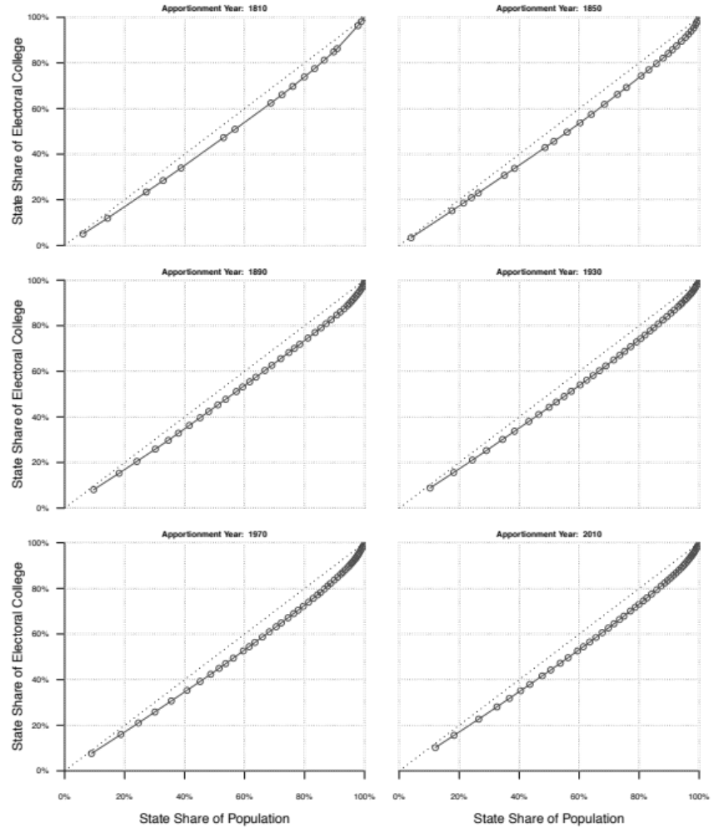

Figure 7: Gini Index Values for the Electoral College: 1790-2010
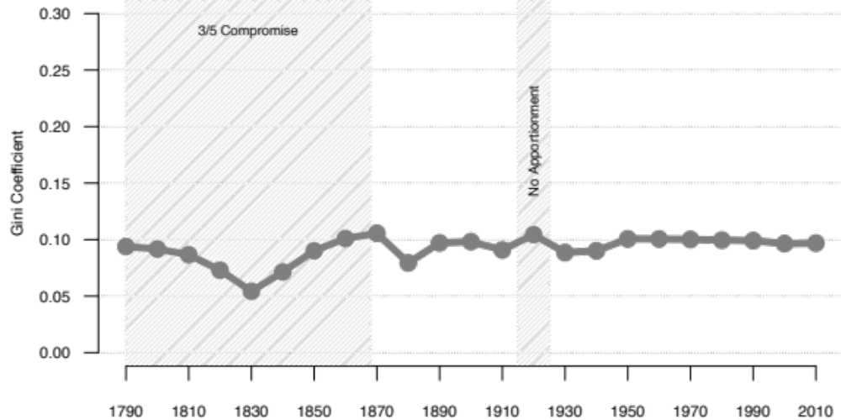

The bivariate correlations for the four measures of EC versus population disproportionality described above are shown in Table 2, along with the correlations for the two measures that look at disproportionality between population and House seat share, as well as, for comparison purposes, the two other measures that we consider, the Gini index and the minimum population proportion needed to reach an Electoral College majority.

<<Table 2 about here>>
Table 2: Bivariate Correlations Among Measures of Disproportionality Between Population and EC Shares and Two Measures of Disproportionality Between Electoral and House-based Allocations
 | Max/Min | Total Population Deviation | EC-Weighted Gallagher | EC-Weighted Loosemore Hanby | Minimum Population | Gini Index | (Average) House Weighted Deviation | (Average) EC Weighted Deviation | House-Weighted Gallagher | House-Weighted Loosemore-Hanby
Max/Min | 1.00 | 0.90 | -0.22 | 0.34 | -0.34 | 0.44 | -0.50 | 0.33 | -0.50 | -0.55
Total  Population  Deviation | 0.90 | 1.00 | -0.35 | 0.44 | -0.47 | 0.55 | -0.64 | 0.43 | -0.65 | -0.74
EC-Weighted  Gallagher | -0.22 | -0.35 | 1.00 | 0.49 | -0.06 | 0.42 | 0.52 | 0.49 | 0.51 | 0.65
EC-Weighted  Loosemore Hanby | 0.34 | 0.44 | 0.49 | 1.00 | -0.70 | 0.99 | -0.33 | 1.00 | -0.33 | -0.28
Minimum  Population | -0.34 | -0.47 | -0.06 | -0.70 | 1.00 | -0.71 | 0.63 | -0.70 | 0.63 | 0.59
Gini Index | 0.44 | 0.55 | 0.42 | 0.99 | -0.71 | 1.00 | -0.38 | 0.98 | -0.38 | -0.34
(Average)  House Weighted  Deviation | -0.50 | -0.64 | 0.52 | -0.33 | 0.63 | -0.38 | 1.00 | -0.33 | 1.00 | 0.96
(Average)  EC Weighted  Deviation | 0.33 | 0.43 | 0.49 | 1.00 | -0.70 | 0.98 | -0.33 | 1.00 | -0.33 | -0.27
House-Weighted  Gallagher | -0.50 | -0.65 | 0.51 | -0.33 | 0.63 | -0.38 | 1.00 | -0.33 | 1.00 | 0.96
House-Weighted  Loosemore-Hanby | -0.55 | -0.74 | 0.65 | -0.28 | 0.59 | -0.34 | 0.96 | -0.27 | 0.96 | 1.00

As we see from Table 2, as previously noted, the first two measures are highly correlated. This is unsurprising given that they essentially measure the same thing, the differences between the largest and smallest state populations. However, most of the remaining EC-related correlations, while positive, are not that high in most cases. The EC-weighted ones are related to bias from the two-seat bonus. The House-weighted measures are based on the rounding effects that are generated by an inability to assign partial Congressmen to states and the requirement that states with populations smaller than the ideal be given one House seat. Because they are picking up two different aspects of disproportionality, with the latter especially sensitive to the number of small states, they need not be highly correlated. We also expect that the first two measures, with are looking at only two states (the largest and smallest), to be generally uncorrelated with the other measures that account for average discrepancies. As can be seen in Table 2, this is indeed the case. The few negatively correlated measures occur because some indices run in opposite directions. For instance, the minimum population measure takes on a smaller value the more disproportionality present.

Effects of House size
While the size of the House continued to grow after 1840, its rate of growth failed to match population growth, and new states with initially small populations joined the Union, particularly in the sparsely populated American West, with another twenty-two states admitted between 1840 and 1912 (Ladewig and Jasinski, 2008). Yet, as noted earlier, in 1929, following the Permanent Apportionment Act, the size of the House was fixed at 435. Fixing the size of the House should, ceteris paribus, have led to continuing increases in malapportionment in 1920 and after. But this did not happen. Indeed, for the EC Max/Min ratio measure, we see from Figure 1 a monotonic decline since 1920, with a peak value in 1900; while for EC total population deviation, we see from Figure 2 that it also has declined in a perfectly monotonic pattern since 1920, with its peak value in 1920. Both measures now have values virtually the same as found in 1850. If we look at House-weighted measures (Figure 4) we see a flat pattern. We wish to explain this counterintuitive result.
To explain this puzzle we need to recognize that population growth patterns strongly affect malapportionment. We can account for the decline or flatness in our various malapportionment measures in recent decades by calling attention to two population growth phenomena. On the one hand, the largest states have grown larger relative to the average state; thus, underrepresentation at the high end has been reduced since the larger states contain more of the total population. On the other side of the coin, the smallest state has grown at roughly the same rate as the mean size of Electoral College seats has grown, so the smallest state is no further away from ideal population equality now than in the recent past, and thus the consequences of overrepresentation of small states is thus reduced or kept essentially constant. These time trends are shown in Figure 8.

<<Figure 8 about here>>
Figure 8: Largest and Smallest State Population, Relative to Mean State Population
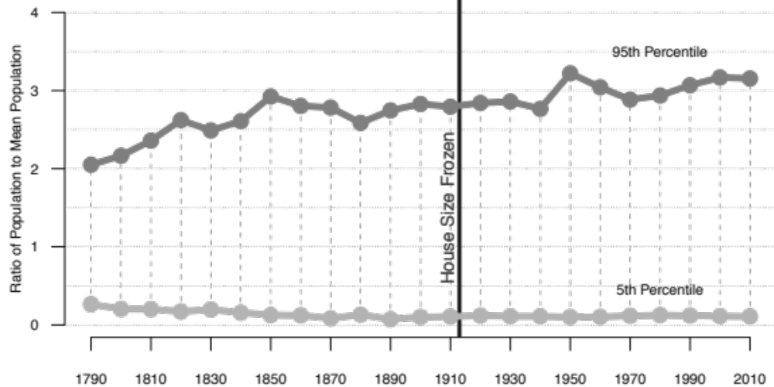

An alternative way to see why we get the minimal pure malapportionment effects we find is to note that, in 1790, if we order states according to overrepresentation, 66.7% of the states (with 44.2% of the population) were needed to reach 50% of the Electoral college; after the 2010 census, 78.4% of the states (with 43.7% of the population) are needed. In fact, the proportion of states in the minimum winning coalition has steadily increased since the founding. Diminishing small state malapportionment bias can also be seen in this measure.

III. Discussion

The goal of this essay has been to address the magnitude of Electoral College bias derived from the purely mechanical effects of rules determining the relationship between EC seat share and state population share, i.e., with no attention paid to actual election results. Though there are many ways we can measure disproportionality in electoral systems, measures such as Gallagher’s Index and the Gini Coefficient are the most appropriate for a system such as the Electoral College which has very unequal units. US Courts have relied on Total Population Deviation, but as we have shown, these measures tend to exaggerate the effects of disproportionality because they focus on the largest and smallest states. This measure might be appropriate for measuring interstate malapportionment, but for the purposes of measuring institutional malapportionment in national governing bodies with varying population totals across states, it provides only a limited view of the overall levels of malapportionment. Once we distinguished average or total level of effects from the worst-case effects, over the period 1789-2010, we found such malapportionment effects quite small, with disproportionality in the Electoral College between EC vote share and state population share not that different from disproportionality of seats and votes among some Western European democracies that use proportional representation rules. Moreover, we found that, generally, malapportionment effects were either flat or decreasing in recent elections compared to those of the late 20th century. In the final section of the paper, we have shown that despite the freezing of the House size, and the logical presumption that malapportionment should increase, shifts in the distribution of population across the states has created a situation where malapportionment has returned to low levels last seen in the 19th century. Based on these analyses, we believe that partisan bias in the Electoral College, to the extent that it exists, cannot be attributed to the purely mechanical effects of malapportionment, but must instead reside in effects that are election-specific, linked to asymmetries in the partisan distribution of electoral support.

REFERENCES

Adkins, Randall E. and Kent A. Kirwan. 2001-2. “What Role Does the ‘Federalism Bonus’ Play in Presidential Selection?” Publius 32 (4) 71-90.
Baker v. Carr, 369 US 186 1962.
Balinski, M. L. and H. Peyton Young. 1982. Fair Representation: Meeting the Ideal of One Man, One Vote. Yale University Press.
Bullock, Charles III. 2010. Redistricting: The Most Political Activity in America. New York: Rowman and Littlefield.
Cox, Gary W. and Matthew S. Shugart. 1991. “Comment on Gallagher’s ‘Proportionality, Disproportionality, and Electoral Systems’.” Electoral Studies. 10:4, 348-352.
Dahl, Robert A. 1971 Polyarchy: Participation and Opposition. New Haven, Conn.: Yale University Press.
Dong, Xiao, Feng Xu and Shiqiang Zhang. 2014. “A Simple and Practical Method of Calculating the Gini Coefficient.” Progress in Applied Mathematics 8 (1): 29-33.
Döring, H. and Manow, P., 2017. “Is Proportional Representation More Favourable to the Left? Electoral Rules and Their Impact on Elections, Parliaments and the Formation of Cabinets.” British Journal of Political Science, 47:149-164.
Edelman, Paul H. 2015. “Voting power apportionments.” Social Choice Welfare. 44, 911-925.
Gallagher, Michael 1991. "Proportionality, Disproportionality and Electoral Systems". Electoral Studies. 10: 33–51.
Grofman, Bernard, William Koetzle, and Thomas Brunell. 1997. “An Integrated Perspective on the Three Potential Sources for Partisan Bias: Malapportionment, Turnout Differences, and the Geographic Distribution of the Party Vote Shares.” Electoral Studies 16: 4, 457-470.
Johnson, Ron. 2002. “Manipulating maps and winning elections: measuring the impact of malapportionment and gerrymandering.” Political Geography, 21, 1-31.
Karpov, Alexander. 2008. “Measurement of Disproportionality in Proportional Representation Systems.” Mathematical and Computer Modelling 48: (9–100), 1421-1438.
Klarman, Michael J. 2016. Framer’s coup: the making of the United States Constitution. Oxford University Press.
Ladewig, Jeffrey W. and Matthew P. Jasinski. 2008. “On the Causes and Consequences of and Remedies for Interstate Malapportionment of the U.S. House of Representatives. Perspectives on Politics 6:1: 89-107.
Loosemore, John, and Vincent Hanby. 1971. “The Theoretical Limits of Maximum Distortion: Some Analytic Expressions for Electoral Systems.” British Journal of Political Science 1: 467-477.
Monroe, Burt L. 1994. “Disproportionality and Malapportionment: Measuring Electoral Inequity.” Electoral Studies 13, 132–49.
Neubauer, M.G and J. Zeitlin. 2003. “Outcomes of Presidential Elections and the House Size.” PS 36 (4): 721–725.
Pattie, Charles, & Ron Johnson. 2014. “The electors shall meet in their respective states”: Bias and the US Presidential Electoral College, 1960-2012”. Political Geography, 40, 34-45.
Riggs, Jack E., Gerald R. Hobbs, and Todd H Riggs. 2009. “Electoral College Winner’s Advantage.” PS: Political Science and Politics, 42(2), 353-357.
Samuels, David & Richard Snyder. 2001. “The Value of a Vote: Malapportionment in Comparative Perspective.” British Journal of Political Science, Vol. 31, No. 4, pp. 651-671.
Taagepera, Rein and Bernard Grofman. 2003. Mapping the Indices of Seats-Votes Disproportionality and Inter-election Volatility.” Party Politics, 9(6):659-677.
Shugurt, Matthew S. & Rein Taagepera. 2017. Votes from Seats: logical models of electoral systems. Cambridge University Press.
Taagepera, Rein & Matthew S. Shugart. 1989. Seats and Votes: The Effects and Determinants of Electoral Systems. Yale University Press.
Wesberry v. Sanders 376 US 1 (1964).

The bonus two electors for each state and the apportionment method not being exactly proportional result in malapportionment. More on this in subsequent sections.
Cf. Grofman, Koetzle and Brunell (1997).
See Balinski and Young (1982).
Malapportionment across states can also occur for the U.S. House of Representatives when Congress fails to fulfill its decennial duty to reapportion the House in accord with new population data. After the 1920 census Congress failed to reapportion the House in accord with new census data (https://www.census.gov/history/www/reference/apportionment/apportionment_legislation_1890_-_present.html). The failure to reapportion after the 1920 census came because of controversy over the need to transfer seats from more rural states whose population was falling, in relative terms, compared to heavily urban states with growing populations. Reapportionment was resumed in 1930 and a rule was set in place that provided for automatic reapportionment after in each census in accord with a specified apportionment formula that provided population based reapportionments. While that formula was changed for the 1940 census, and a still different formula had been used early in the nation’s history https://www.census.gov/population/apportionment/about/history.html, the differences in allocation across apportionment formulae, tend to be minor (see Balinski and Young, 1982). Within states, malapportionment of congressional seats or legislative seats can occur when the redistricting that does take place violates principles of one person, one vote. Prior to Baker v. Carr (1962) and the subsequent one person, one vote cases, especially for state legislatures, this could be a major problem. In particular, some state constitutions, such as that in Georgia, which used counties as its redistricting units, had state constitutional provisions that required redistricting that was not entirely (or even mostly) based on population. Tennessee, whose constitution required decennial redistricting, but which had not redistricted its legislature since 1901, had its grossly malapportioned legislative districts challenged in Baker v. Carr (1962), and the state was compelled to redistrict. However, pre-Baker v. Carr, while most state legislatures (especially upper chambers) were more malapportioned than the U.S. House districts in the state, there were also states whose House seats were also severely malapportioned. For example, in 1962 Georgia’s largest House seat had more than twice the population of its smallest House district (Bullock, 2010: 141).
To echo other work that looks at measures of disproportionality, no single measure can capture every feature of interest, and each measure has some desirable properties and some flaws (Cox and Shugart 1991, Monroe 1994; Taagepera and Grofman, 2003).
Samuels and Snyder (2001) use the Loosemore-Hanby index to measure comparative malapportionment in both upper and lower chambers of national assemblies. They find that the US has a low level of malapportionment in the US House, but a relatively high amount in the US Senate.
Only when malapportionment effects go in the same direction as partisan vote asymmetry effects, i.e. only when one party disproportionally wins the states that are most advantaged by Electoral College malapportionment, could malapportionment explain the divergence between popular vote share and EC outcomes. In actuality, pure malapportionment effects are outweighed by the nature of the actual vote distribution across states as shaped by the Electoral College’s winner take all feature.
The discrepancy could still be caused by the partisan distribution of voters across states, or turnout differences among the states. Additionally, the size of the house itself might have affected the outcome in 2000 as Neubauer and Zeitlin (2003) point out, but given the magnitude of Trump’s EC victory, the House size would have to have been increased toward infinity to switch the outcome. This is beyond the scope of this study.
See e.g., Wesberry v. Sanders 376 U.S. 1 (1964)
For total population deviation, the worst case occurs with all states having virtually identical populations, but with only the largest of the N states getting any seats. Of course, the actual Electoral College rules we use prevent such a worst case scenario. In particular, given present rules, with 51 states each of which gets a minimum of three Electoral College seats, the worst case scenario has a total population deviation of 538/388= 1.39, which occurs when virtually all population is concentrated in a single state.
As long as total population can continue to grow, both measures of malapportionment are essentially unbounded.
This can occur when another state is roughly the same size as the smallest state but peculiarities of the rounding process lead to overrepresentation of the larger of the two states. For instance, in 1790 Delaware had only a slightly lower population than Rhode Island, but due to the rounding formula used in apportionment, Rhode Island had one more congressional seat and thus one additional Electoral College vote, and was more overrepresented in the Electoral College than Delaware, even though Delaware was the smallest state at the time. After 1810 (except in 1830 and 1850), New York had the largest population but the state with the largest population often was not the most underrepresented in the EC relative to population because of the same type of rounding complication. This happened in 1800, 1810, 1820, 1830, 1840, 1850, 1860, 1880, 1920, and 1950, while in 1960 there were two states that were more underrepresented than New York. California surpassed New York as the largest state in 1970, but in 1970 it was not the most underrepresented state.
In the 1840 reapportionment, the House size was reduced for the only time in U.S. history, from 240 to 223. It grew again throughout that decade as new states were added. See data and charts in Ladewig and Jasinski (2010).
Set by Public Law 62-5 on August 8, 1911 and taking effect in 1913.
When Alaska and Hawaii became the 49th and 50th states, and Washington D.C. was extended the franchise by way of the Twenty-Third Amendment in 1961.
If the populations of the various states are fixed, if House size grows, then malapportionment due to House rounding effects should decrease (Ladewig and Jasinski, 2008). See later discussion of House size effects.
We deliberately use the term ‘potential’ bias because, as previously mentioned in the text, in any given election year, the observed partisan bias attributable to malapportionment will depend upon the actual distribution of votes across the states,
For further justification of these measures, see e.g. Taagepera and Grofman (2003).
2017 Dutch Election: Loosemore-Hanby – 0.013, Gallagher – 0.006. Data source: https://www.kiesraad.nl/
2015 Knesset Election: Loosemore-Hanby – 0.015, Gallagher – 0.007. Data source: https://www.knesset.gov.il
Tabulating data from Doring and Manow (2015: Table 3.p. 159) shows that proportional countries have an average Gallagher least squares disproportionality of 2.4, while majoritarian countries average 9.6. The disproportionality in the Electoral College in 2016 was 2.06.
They do tell different stories about the difference between House-weighted and EC-weighted Loosemore-Hanby measures. The difference between the House-weighted and EC-weighted Loosemore-Hanby measure has reached historic highs over the past few decades, while the difference between the House-weighted and EC-weighted Gallagher measure has remained at low levels since after the Civil War. We interpret these differences as attributable to the different ways the two measures handle discrepancies in small states, and we believe the Gallagher index to be the more informative (cf. Karpov 2008). The House-based disproportionality during the period when slaves were counted as 3/5th was much larger than modern apportionment because, for comparability reasons, we are calculating disproportionality in the pre-1870 decades in terms of the current apportionment formula. There is an increase in 1920 in both measures due to the House failing to reapportion, so states that had gained population in the previous decade still had the same representation based on the 1910 census.
It’s not always true that ordering the states in this way gives the minimum population needed to reach a majority in the EC. Consider 1830: the minimum reported in Figure 4 is 50.9%, but the lowest possible minimum population is 47.5%, which can be obtained by including in the minimum winning coalition North Carolina and excluding Kentucky, even though the latter has a larger population than the former by over 20,000.
If we divide this number by two, this gives us, in effect, the minimum proportion of the U.S. population sufficient to control a majority of Electoral College seats. Some scholars who marshalled evidence for the unfairness of redistricting practices in state legislatures in the periods before and just after Baker v. Carr made use of a measure analogous to the first of the measures described above (see Table 2.1 in Bullock, 2010: 30-31, which reports various estimates of legislative disproportionality that are contemporaneous with Baker v. Carr).
Again, we include the District of Columbia only since 1960.
We also checked these calculations in two ways. First, we calculated the Gini index by using a piecewise linear approximation and then finding and summing the area under the resultant triangles and rectangles. Second, we made use of an approximation formula that was independently proposed by one of the present authors but which yields results that are closely related to the work of Dong et al. (2014). That approximation method posits that the relationship between cumulative EC vote share and cumulative population share is given by cumulative EC vote share = (cumulative population share) raised to the a^{th} power, where a is expected to be a number above 1. To estimate a, we take logs to obtain ln(cumulative EC vote share) = a * ln(cumulative population share) and run a simple OLS, but forcing the line to have a zero intercept. When we use the value of a so obtained and, for that value of a, take the definite integral between zero and one of the original formula, we find the area under the curve as 1/(a+1), so that the Gini index becomes 2 *[½ - 1/(a+1)] where the ½ is the area of the triangle specified by the forty-five degree line and the axes, and the two is a normalizing factor to insure that the index runs between zero and one. The correlation among these various approximations is very high, and they yield nearly identical Gini values.
For example, for comparison purposes, the Gini index for income inequality in the U.S. is now close to 0.4 (http://iresearch.worldbank.org/PovcalNet/povOnDemand.aspx). Income inequality and democratic institutions are not directly comparable because democracy theory expects our political institutions to be equal but capitalism doesn’t have the same expectations.
Temporary increases in House size to 437 occurred in 1959 with the admission of Hawaii and Alaska.
Of our six measures, only the index discussed in the Appendix that calculates the minimum proportion of the population need to secure an Electoral College majority (Belenky, 2005), shows any evidence of a 1929 effect, and even that measure is virtually flat in recent decades.
Data omitted for space reasons.

